**과제 1**

1. 전체 구매 고객에 대하여 고객별 총 구매 금액 출력

SELECT C.CustomerID, SUM(D.Quantity*P.Price) AS '총 구매 금액'

FROM Orders AS O

JOIN Customers AS C ON O.CustomerID=C.CustomerID

JOIN OrderDetails AS D ON O.OrderID = D.OrderID

JOIN Products AS P ON D.ProductID = P.ProductID

GROUP BY C.CustomerID

ORDER BY O.OrderID;

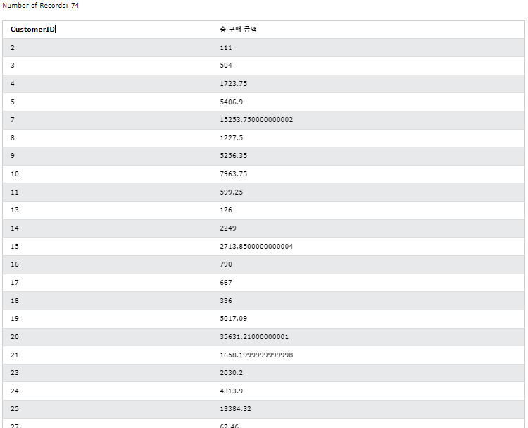

1. 2000개 이상의 판매가 이러우진 상품의 카테고리 이름과 총 판매량, 총 판매 금액 출력하기

SELECT C.CategoryName, SUM(D.Quantity) AS '총 판매량', SUM(D.Quantity*P.Price) AS '총 판매 금액'

FROM Categories AS C

JOIN Products AS P ON C.CategoryID = P.CategoryID

JOIN OrderDetails AS D ON P.ProductID = D.ProductID

JOIN Orders AS O ON D.OrderID = O.OrderID

GROUP BY C.CategoryID

HAVING SUM(D.Quantity)>=2000

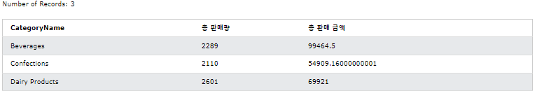

**과제 2**

제1정규형

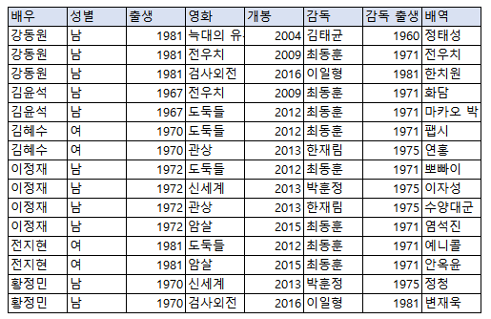

제2정규형

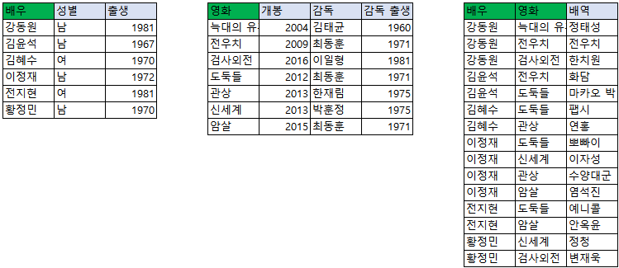

제3정규형

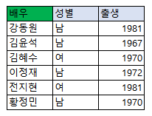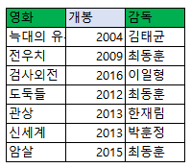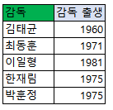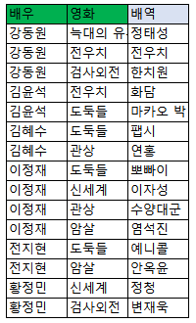

BCNF

